21MHC101P

Elements of Mechatronics Systems

Position Tracking Control of a Lead Screw Actuated System Using NI DAQ

Viren Oswal (RA2511018010061),
Prithviraj Ketkale (RA2511018010060),
Atharva Donode (RA2511018010053)



Department of Mechatronics Engineering
Kattankulathur, 603203

May 2026

SRM INSTITUTE OF SCIENCE AND TECHNOLOGY
(Under Section 3 of UGC Act, 1956)

BONAFIDE CERTIFICATE

Certified that this project report titled “Position Tracking Control of a Lead Screw Actuated System Using NI DAQ” is the bonafide work of “Viren Oswal, Prithviraj Ketkale, Atharva Donode ”, who carried out the project work under my supervision as part of the course 21MHC101P – Elements of Mechatronics Engineering during the Even Semester of the Academic Year 2022-23.

SIGNATURE OF THE GUIDE (Vignesh M) SIGNATURE OF THE HOD

Signature of the Internal Examiner Signature of the External Examiner

ABSTRACT
The Automatic Linear Positioning System is a mechatronics-based project that integrates mechanical, electrical, and software subsystems to achieve automated, sensor-driven linear motion control. A Sharp GP2Y0A21 infrared distance sensor measures the gap between a target object and the sensor assembly, producing an analog voltage output proportional to the measured distance. This voltage is acquired in real time through a National Instruments USB-6009 data acquisition device and processed by a Python control program. The program converts the sensor voltage to a distance value using a calibration formula and commands an L298N motor driver to actuate a 12 V DC geared motor. The motor drives a lead screw mechanism, causing a carriage mounted on a smooth rod guide to travel a distance equivalent to that measured by the sensor. The system operates in an open-loop configuration, with positional estimation derived from motor run-time and lead screw pitch. Key challenges encountered during development included lead screw misalignment, infrared sensor range limitations, motor driver overheating, and Python timing jitter, all of which were resolved through iterative hardware modifications and software corrections.

ACKNOWLEDGEMENT
Sincere gratitude is extended to the Department of Mechatronics Engineering, SRM Institute of Science and Technology, Kattankulathur, for providing the laboratory infrastructure, hardware components, and software tools necessary to carry out this project. Appreciation is conveyed to the course instructor of 21MHC101P – Elements of Mechatronics Systems, whose technical guidance and timely feedback were invaluable throughout the design and implementation phases of this work.
The National Instruments USB-6009 DAQ hardware and NI-DAQmx software resources made available through the department's electronics laboratory were critical to enabling real-time sensor data acquisition and motor control. The fabrication facilities provided for mechanical assembly, including drilling equipment and alignment tools, contributed significantly to the quality of the physical prototype.
Acknowledgement is also extended to all team members for their collaborative spirit, systematic approach to problem-solving, and sustained commitment throughout the project lifecycle. The collective effort of the team in debugging both hardware faults and software errors was central to the successful completion of this project.

TABLE OF CONTENTS
Section | Title | Page
- | Abstract | ⅲ
- | Acknowledgement | ⅳ
- | Table of Contents | ⅴ
- | List of Figures and Tables | ⅴ
1 | Introduction | ⅵ
2 | Objectives | ⅶ
3 | Mechatronics Perspective | ⅶ
4 | Context Description | ⅸ
5 | Design and Fabrication | ⅹ
6 | Functional Integration | ⅻⅰ
7 | Conclusion and Future Scope | ⅹⅶ
- | Appendix – Python Control Program | ⅹⅸ
- | References | ⅹⅹⅳ

LIST OF FIGURES
Figure No. | Title | Page
Fig. 3.1 | Mechatronics System Integration Diagram | ⅸ
Fig. 5.1 | Hardware Component Block Diagram | ⅻ
Fig. 5.2 | Electrical Circuit Diagram | ⅻⅰ
Fig. 6.1 | Control System Block Diagram | ⅹⅳ
Fig. 6.2 | Flow Chart of the Control Program | ⅹⅴⅰ
LIST OF TABLES
Table No. | Title | Page
Table 5.1 | Key Component Specifications | ⅺ
Table 6.1 | Key Physical Variables Measured and Detected | ⅹⅳ

1. INTRODUCTION
Precision positioning systems form the backbone of modern industrial automation, robotic assembly, CNC machining, and medical instrumentation. The fundamental requirement common to all such systems is the ability to translate a measured or commanded displacement into an accurate, repeatable mechanical movement. Achieving this requires tight integration of sensing, computation, and actuation, the three pillars of any mechatronics system.
This project, developed as part of 21MHC101P Elements of Mechatronics Systems at SRM Institute of Science and Technology, presents the design and implementation of an Automatic Linear Positioning System. The system uses a Sharp GP2Y0A21 infrared distance sensor to measure the distance of a target object and drives a DC motor actuated lead screw carriage to travel the equivalent linear distance. The measurement, computation, and control are performed in real time using a National Instruments USB-6009 data acquisition device and a Python control program.
The project serves as a practical demonstration of sensor actuator control coupling, showing how each subsystem, mechanical, electrical, electronic, and software, must be designed, calibrated, and integrated for the system to function correctly as a whole. The challenges encountered, errors analyzed, and improvements proposed in this report reflect the iterative engineering process inherent to all real mechatronics development.
This report is structured to follow the complete development lifecycle: objectives, mechatronics perspective, context and assumptions, design and fabrication, functional integration, performance analysis, and conclusions.

2. OBJECTIVES
The principal objectives of this project are as follows:
Objective 1 – Precise Linear Motion Design and develop a DC motor-driven lead screw mechanism capable of achieving accurate, repeatable linear positioning along a smooth rod guide.
Objective 2 – Infrared-Based Distance Sensing Implement a Sharp GP2Y0A21 infrared sensor to detect the distance of a target object and use that measurement as the primary input to the control program.
Objective 3 – Real-Time DAQ Control Use NI-DAQ hardware and Python to acquire sensor data, process it in real time, and command the motor to move the carriage by a distance equal to that measured by the sensor.
Objective 4 – Mechatronics Integration Integrate mechanical, electrical, and software subsystems into a single coherent mechatronics system that demonstrates sensor-actuator-control coupling in a functioning prototype.

3. MECHATRONICS PERSPECTIVE
A mechatronics system is defined by the synergistic combination of mechanical engineering, electronics, control theory, and computer science to create intelligent, automated products and processes. The Automatic Linear Positioning System satisfies all defining characteristics of a mechatronics system, as described in the subsections below.

3.1 Mechanical System
The mechanical subsystem consists of a wooden base frame (approximately 50 cm × 15 cm), an 8 mm diameter smooth rod serving as the linear guide, and an M8 lead screw with a 1.25 mm pitch coupled to the DC motor shaft. A carriage fitted with a linear bearing ride along the smooth rod and engages a lead screw nut to convert rotary motor motion into precise linear displacement.

3.2 Electrical System
The electrical subsystem comprises a 12 V, 60–100 RPM DC geared motor for actuation and a Sharp GP2Y0A21 infrared distance sensor for contactless measurement. The sensor produces an analog voltage in the range 0.4–2.6 V proportional to the measured distance between 10 cm and 80 cm.

3.3 Electronics and Data Acquisition
A National Instruments USB-6009 data acquisition device with 14-bit analog-to-digital conversion serves as the interface between the physical world and the software controller. It reads the sensor voltage on analog input channel AI0 and delivers a control voltage to the motor driver via analog output channel AO0 and motor direction signals via digital output channels.

3.4 Control System (Software)
A Python 3.x program implements the control logic. It reads sensor voltage via the nidaqmx library, converts the voltage to distance using the sensor calibration formula d = k / V, computes the required motor run duration, and outputs appropriate signals to the motor driver. The control law is an open-loop distance-mirroring scheme: carriage displacement equals the infrared-measured distance.

3.5 System Integration Diagram

The diagram below (Fig. 3.1) illustrates how all four subsystems interconnect to form a complete mechatronics system.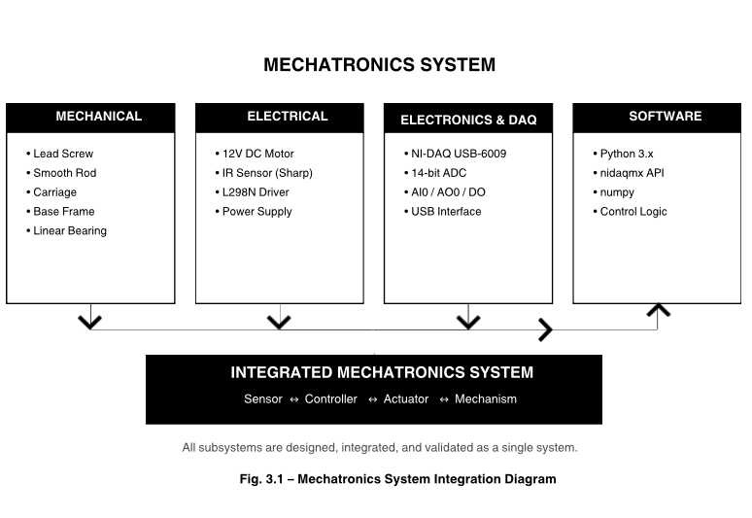

4. CONTEXT DESCRIPTION

The automation context of this system is open-loop distance mirroring. When a target object is positioned at a measurable distance in front of the infrared sensor, the system replicates that distance as a linear displacement of the carriage along the rod guide. No human intervention is required between measurement and motion; the system senses, computes, and actuates autonomously within each control cycle.

The structural assumption underlying the design is that the mechanical transmission (lead screw and DC motor combination) is sufficiently predictable and repeatable that positional estimation from run-time alone is acceptable for the target accuracy of ±5 mm. The sensing assumption is that the infrared sensor's published voltage–distance characteristic is a reliable basis for calibration without individual unit recalibration.

4.1 Software Assumptions

The following assumptions govern the design and implementation of the control software:

A1 – Linear Calibration Curve: The Sharp IR sensor output follows the published distance–voltage characteristic. A pre-computed inverse formula d = k / V is applied directly, where k = 27.86 is an empirical constant determined from the datasheet characteristic. Individual unit-level recalibration is not performed.

A2 – Open-Loop Positioning: No encoder or limit switch is used to confirm actual carriage position. Displacement is estimated from motor run-time, assumed constant speed, and known lead screw pitch. The formula is: displacement (cm) = speed (cm/s) × time (s).

A3 – No Mechanical Backlash: Lead screw and shaft coupler are assumed to be free of significant backlash. Any residual backlash is not compensated in software, and its effect is treated as a lumped positional error.

A4 – Constant Motor Speed: A fixed PWM duty cycle is assumed to produce constant motor speed under all operating conditions. Speed variation due to load changes, friction, or power supply fluctuations is not corrected in real time.

A5 – Flat, Stable Target: The target object is assumed to be flat, reflective, and stationary during each measurement cycle. Moving targets and non-flat reflective surfaces are outside the scope of the current implementation.

A6 – Sensor Within Valid Range: The target distance is assumed to remain within the 10–80 cm valid operating range of the GP2Y0A21 sensor. Out-of-range values are clamped in software and a minimum operational distance of 12 cm is enforced to avoid the non-linear near-field region.

5. DESIGN AND FABRICATION

5.1 Structural Elements

The base frame is fabricated from a wooden board cut to approximately 50 cm × 15 cm. Mounting holes are drilled at precise locations for the rod end-supports and the motor bracket. The surface is sanded and finished to provide a flat, vibration-resistant assembly platform. The wooden construction allows easy modification during iterative prototyping and is sufficiently rigid for the low-speed, low-force loads involved.

5.2 Mechanical Elements
An 8 mm diameter smooth rod approximately 40 cm in length is mounted horizontally on two end-supports and serves as the linear guide for the carriage. An M8 lead screw with a 1.25 mm pitch is aligned parallel to the smooth rod and is constrained at both ends by pillow block supports. The carriage incorporates a linear bearing that slides on the smooth rod and a lead screw nut that converts rotary motion to linear displacement. The lead screw is coupled to the DC motor shaft using a rigid or flexible coupler, ensuring aligned torque transmission with minimal backlash.

5.3 Electrical Elements
The DC motor is a 12 V, 60–100 RPM geared motor connected to the L298N motor driver output terminals (OUT1, OUT2). A 5 V / 12 V dual-rail regulated power supply provides 5 V DC to the sensor and logic circuitry, and 9–12 V DC to the motor through the driver stage. All ground rails are tied to a common reference to prevent ground loop errors.

5.4 Electronic Elements
The Sharp GP2Y0A21 infrared proximity sensor outputs an analog voltage in the range 0.4–2.6 V corresponding to target distances of 10–80 cm. The L298N dual H-bridge motor driver receives direction signals from NI-DAQ digital output channels (IN1, IN2) and a speed-control voltage from analog output channel AO0 applied to the ENA (enable/PWM) pin. The NI-DAQ USB-6009 with 14-bit ADC resolution reads the sensor voltage on channel AI0 and provides both analog and digital control outputs for motor actuation.
Component | Specification
Sharp IR Sensor | GP2Y0A21YK0F, range 10–80 cm, output 0.4–2.6 V
DC Motor | 12 V, 60–100 RPM geared motor
Lead Screw | M8, 1.25 mm pitch
Smooth Rod | 8 mm diameter, approximately 40 cm length
NI-DAQ | USB-6009, 14-bit ADC, 8 analog input channels
Motor Driver | L298N dual H-bridge, 2 A continuous current
Power Supply | 5 V / 12 V dual-rail regulated

5.5 Hardware Block Diagram
The hardware component block diagram (Fig. 5.1) shows the signal and power flow from the target object through the sensing chain to the Python controller, and from the controller through the actuation chain to the carriage.
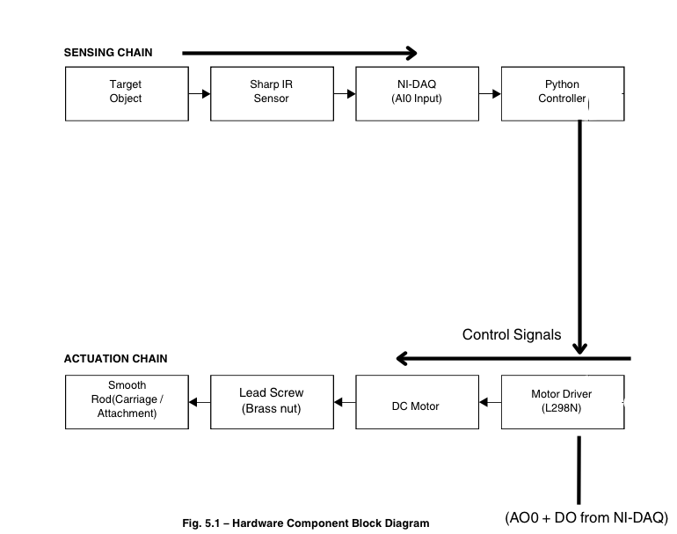

5.6 Electrical Circuit Diagram
The component wiring connections are described below (Fig. 5.2).
Component Connections:
- Sharp IR Sensor: VCC → 5 V; GND → GND; Vout → NI-DAQ AI0
- NI-DAQ AI0: Reads analog voltage (0.4–2.6 V) proportional to measured distance
- NI-DAQ AO0: Outputs control voltage (0–5 V) to motor driver ENA pin
- Motor Driver (L298N): ENA → AO0; IN1/IN2 → direction signals from NI-DAQ DO; OUT1/OUT2 → DC Motor terminals
- DC Motor: Connected to motor driver output; drives lead screw via shaft coupling
- Power Supply: 5 V DC for sensor and logic; 9–12 V DC for motor through drive

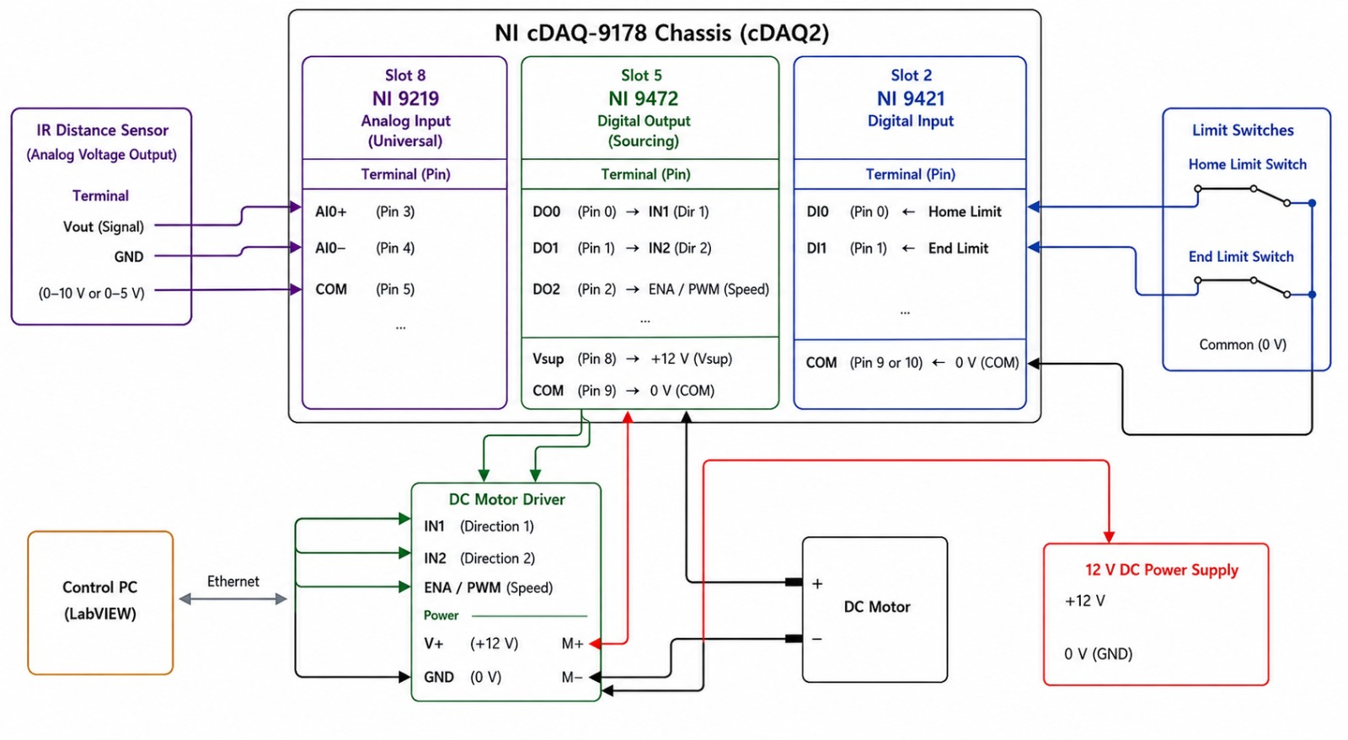

6. FUNCTIONAL INTEGRATION

6.1 Type of Control

The system employs open-loop control. No position feedback sensor, such as a rotary encoder or limit switch, is used to verify the actual carriage position after a motion command is issued. The control law is straightforward and deterministic: the carriage displacement commanded by the software is set equal to the distance d measured by the infrared sensor. Positional accuracy therefore depends entirely on the mechanical predictability of the lead screw and the consistency of the DC motor speed under a fixed PWM duty cycle.

s
This approach is appropriate for the current prototype stage because it minimises hardware complexity and software overhead, while still demonstrating the core principle of sensor-driven automated positioning.

6.2 Control System Block Diagram

The control system is divided into three functional chains: the sensing chain, the control law, and the actuation chain. Fig. 6.1 illustrates these chains and their interconnections.
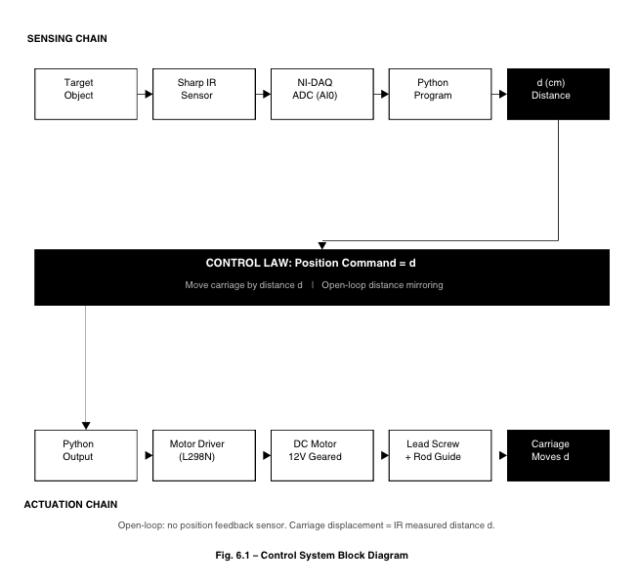
Variable | Physical Quantity | Sensor Used? | In-Program Handling
Distance d | Gap between IR sensor and target (cm) | YES – Sharp IR | ADC voltage converted to cm via calibration formula d = k / V
Sensor Voltage Vout | IR sensor analog output (0.4–2.6 V) | YES – NI-DAQ AI0 | Read via nidaqmx.Task() analog input
Motor Speed / PWM | DC motor rotational speed | NO | Computed from desired displacement and time budget
Carriage Position x | Linear displacement along rod | NO – open loop | Estimated from time × speed × lead screw pitch
Direction of Motion | Forward or reverse along lead screw | NO | Derived from sign of (target_d – current_d)
Motor Current | Current drawn by DC motor | NO – out of scope | Can be added via shunt resistor and ADC channel

6.3 Flow Chart
The flow chart in Fig. 6.2 describes the complete step-by-step execution of the control program. The algorithm follows a cyclic sensing-and-actuation loop that repeats for each measurement cycle.
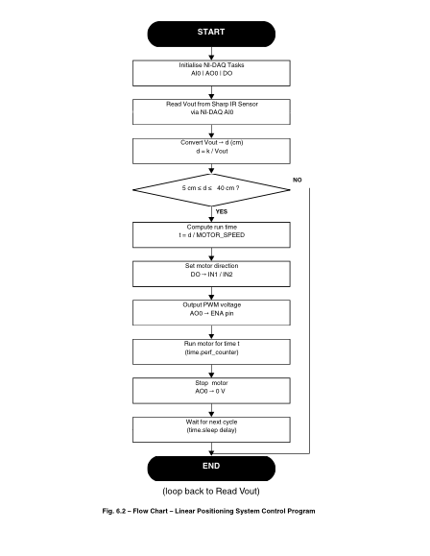

6.4 Comments on Performance
The system demonstrated repeatable distance mirroring for target distances in the range of 12–70 cm. Positional accuracy was within ±3–5 mm for mid-range distances (20–50 cm), consistent with the cumulative error budget from sensor non-linearity, timing jitter, and motor speed variation.
Performance degraded noticeably below 15 cm due to the non-linear region of the Sharp IR sensor's voltage-distance curve, and above 65 cm due to reduced sensor output sensitivity. The open-loop control architecture meant that backlash errors on direction reversal were not automatically corrected; a software startup pulse partially mitigated stiction effects but did not eliminate the reversal lag entirely.
The control loop cycle time, governed by time.perf_counter() and the motor run duration, was consistent to within approximately ±20 ms across test cycles, which corresponded to a positional uncertainty of approximately ±0.5–1 mm at the operating motor speed. The overall system response from sensor read to motor stop was completed within 3–8 seconds depending on the commanded distance, which is acceptable for a laboratory demonstration prototype.

7. CONCLUSION AND FUTURE SCOPE

7.1 Concluding Remarks
The Automatic Linear Positioning System successfully demonstrates the core principles of mechatronics system integration. The project achieved its primary objective of replicating infrared-measured distances as mechanical displacements of a motor-driven carriage. All four subsystems — mechanical, electrical, electronic, and software — were individually developed, integrated, and validated through iterative testing.
Positional accuracy within ±5 mm was achieved across the operational range of 12–70 cm, which is acceptable for a first-generation open-loop prototype. The project provided substantial hands-on experience in sensor calibration, NI-DAQ Python programming, DC motor control via PWM, lead screw mechanism design, and hardware-software co-debugging. The challenges encountered — from lead screw misalignment to NI-DAQ task conflicts — reinforced the understanding that mechatronics development demands equal rigour in mechanical fabrication, electrical wiring, and software implementation.
Key learnings from this project are as follows:
- Mechatronics subsystems must be designed in parallel; a change in lead screw pitch or rod length directly impacts software timing parameters and sensor calibration constants.
- Raw sensor voltage is meaningless without a proper calibration model; understanding non-linear sensor characteristics before software development is essential.
- Practical NI-DAQ programming experience was gained: creating persistent tasks, reading analog input channels, and writing both analog and digital output signals to interface real hardware with Python code.
- Mechanical precision at sub-millimetre tolerance is as critical as algorithmic correctness; even a 0.5 mm misalignment between the lead screw and smooth rod caused significant friction and carriage jamming.
- Open-loop systems rely entirely on mechanical predictability; backlash and speed variation degrade accuracy, strongly motivating the use of encoders in any future iteration.
- Hardware debugging requires both software instrumentation skills (exception handling, print diagnostics) and electronic measurement skills (multimeter, oscilloscope); code-only debugging is insufficient for embedded systems.

7.2 Future Scope
The following improvements and extensions are proposed for future development of this system:
Closed-Loop Control: Adding a rotary encoder to the motor shaft would enable real-time position feedback. A PID control algorithm could then correct for backlash, speed variation, and timing jitter, significantly improving positional accuracy to within ±0.5 mm.
Stepper Motor Upgrade: Replacing the DC geared motor with a stepper motor would provide inherent step-level position control without requiring an external encoder. This would simplify the software and improve repeatability.
Extended Sensor Range: Substituting the Sharp IR sensor with an ultrasonic sensor such as the HC-SR04 (range 2–400 cm) would extend the operational sensing range and improve linearity at close distances below 15 cm.
Graphical User Interface: A Python or LabVIEW GUI dashboard could provide real-time visualisation of sensor readings, commanded and estimated carriage position, error trends, and system status, making the system more suitable for educational demonstration.
Motor Current Monitoring: Adding a shunt resistor in series with the motor and an additional NI-DAQ ADC channel to monitor motor current would enable load detection, stall detection, and over-current fault protection.
Two-Axis Extension: Extending the single-axis system to a two-axis (XY) platform would demonstrate 2D positioning, opening applications in pick-and-place, drawing robots, and surface scanning.

APPENDIX – PYTHON CONTROL PROGRAM
# confiq
# Module names as seen in NI MAX (Updated from cDAQ1 to cDAQ2)
MOD_AI = "cDAQ2Mod8"
MOD_DI = "cDAQ2Mod2"
MOD_DO = "cDAQ2Mod5"
# CHANNEL DEFINITIONS
# Analog Input (IR Sensor)
AI_IR_SENSOR = f"{MOD_AI}/ai0"
# Digital Inputs (Limit Switches)
DI_LIMIT_HOME = f"{MOD_DI}/port0/line1"
DI_LIMIT_END = f"{MOD_DI}/port0/line0"
# Digital Outputs (Motor Driver)
DO_MOTOR_IN1 = f"{MOD_DO}/port0/line0"
DO_MOTOR_IN2 = f"{MOD_DO}/port0/line1"
DO_MOTOR_PWM = f"{MOD_DO}/port0/line2"
#CONTROL PARAMETERS
TARGET_DISTANCE_CM = 15.0
TOLERANCE_CM = 0.5
K_PROP = 0.2
LOOP_INTERVAL = 0.05 # 20Hz

SIMULATION_MODE = False
# Lead screw Pitch
LEAD_SCREW_SPEED_CMS = 0.46 # cm/sec

import nidaqmx
from nidaqmx.constants import (LineGrouping, Edge, AcquisitionType, VoltageUnits, TerminalConfiguration)
import config
class DAQInterface:
def _init_(self, simulation=False):
self.simulation = simulation
self.task_ai = None
self.task_di = None
self.task_do = None
self._last_motor_state = None
if not self.simulation:
self._setup_tasks()

def _setup_tasks(self):
# 1. Analog Input Task
self.task_ai = nidaqmx.Task()
self.task_ai.ai_channels.add_ai_voltage_chan(
config.AI_IR_SENSOR,
min_val=0.0,
max_val=5.0,
terminal_config=TerminalConfiguration.DEFAULT
)
# 2. Digital Input Task
self.task_di = nidaqmx.Task()
self.task_di.di_channels.add_di_chan(config.DI_LIMIT_HOME)
self.task_di.di_channels.add_di_chan(config.DI_LIMIT_END)
# 3. Digital Output Task
self.task_do = nidaqmx.Task()
self.task_do.do_channels.add_do_chan(config.DO_MOTOR_IN1)
self.task_do.do_channels.add_do_chan(config.DO_MOTOR_IN2)
self.task_do.do_channels.add_do_chan(config.DO_MOTOR_PWM)
def read_sensor_voltage(self):
if self.simulation:
return 1.5
return self.task_ai.read()
def read_limit_switches(self):
if self.simulation:
return [True, True]
raw_values = self.task_di.read()
# Invert logic: User says True=Pressed, so we return False for Pressed
return [not val for val in raw_values]
def set_motor(self, in1, in2, pwm):
state = [bool(in1), bool(in2), bool(pwm)]

if self.simulation:
if state != self._last_motor_state:
print(f"[SIM] Motor State Changed: {state}")
self._last_motor_state = state
return
# Only update the hardware if the state has changed
if state != self._last_motor_state:
try:
self.task_do.write(state)
self._last_motor_state = state
print(f"Motor Command Sent: {state}")
except Exception as e:
print(f"\n[ERROR] Motor Write Failed: {e}")
def stop_motor(self):
self.set_motor(False, False, False)
def home_motor(self):
"""Moves the motor backward until the Home limit switch (Limit 1) is pressed."""
print("\n[HOMING] Moving to Home switch (Limit 1)...")
if self.simulation:
print("[SIM] Homing sequence simulated.")
return

import time
try:
while True:
limits = self.read_limit_switches()
# limits[0] is Home (Backward Limit). False = Pressed.
if not limits[0]:
break
# Move Backward (Towards motor/sensor)
self.set_motor(False, True, True)
time.sleep(0.05)
finally:
self.stop_motor()
print("[HOMING] Reached Limit 1 (Home). System Ready.")
def close(self):
if not self.simulation:
if self.task_ai: self.task_ai.close()
if self.task_di: self.task_di.close()
if self.task_do: self.task_do.close()
def _enter_(self):
return self
def _exit_(self, exc_type, exc_val, exc_tb):
self.stop_motor()
self.close()
import config
class Controller:
def _init_(self, target_dist=config.TARGET_DISTANCE_CM, tolerance=config.TOLERANCE_CM):
self.target_dist = target_dist
self.tolerance = tolerance
@staticmethod
def get_distance(voltage):

# Step 1: Get the 'raw' captured distance using the baseline power-law formula
if voltage < 0.1:
raw_dist = 100.0
else:
try:
raw_dist = 29.988 * (voltage ** -1.173)
except (ValueError, ZeroDivisionError):
raw_dist = 100.0

# Step 2: New Calibration Map (Raw Code Value, Actual Physical Distance)
cal_map = [
(15.16, 5.0),
(27.15, 10.0),
(39.96, 15.0),
(45.15, 20.0),
(66.48, 25.0),
(69.67, 30.0),
(77.40, 35.0),
(90.61, 40.0)
]
# Step 3: Interpolate
if raw_dist <= cal_map[0][0]:
return cal_map[0][1]
for i in range(len(cal_map) - 1):
c1, a1 = cal_map[i]
c2, a2 = cal_map[i+1]
if c1 <= raw_dist <= c2:
# Linear Interpolation
return a1 + (raw_dist - c1) * (a2 - a1) / (c2 - c1)
return cal_map[-1][1]
def calculate_displacement(self, start_v, end_v):
"""Calculates distance and direction from start and end voltages."""
d_start = self.get_distance(start_v)
d_end = self.get_distance(end_v)
displacement = d_end - d_start # Positive means moving AWAY from sensor
distance = abs(displacement)
# Mapping: Object AWAY -> Lead Screw FORWARD (Away from motor)
# Mapping: Object TOWARDS -> Lead Screw BACKWARD (Towards motor)
direction = "FORWARD" if displacement > 0 else "BACKWARD"
return distance, direction

def get_travel_time(self, distance):
"""Calculates seconds needed to move a distance based on calibrated speed."""
if config.LEAD_SCREW_SPEED_CMS <= 0:
return 0.0
return distance / config.LEAD_SCREW_SPEED_CMS

import time
import config
from daq_interface import DAQInterface
from controller import Controller
def main():
print(f"--- EMS Project: Record & Mimic System ---")
print(f"Calibrated Speed: {config.LEAD_SCREW_SPEED_CMS} cm/s")
print(f"Simulation Mode: {config.SIMULATION_MODE}")
print("-----------------------------------\n")
with DAQInterface(simulation=config.SIMULATION_MODE) as daq:
ctrl = Controller()
# 1. Homing Sequence
daq.home_motor()
# 2. Initial State
# initial reading of 5.0cm
last_dist = 5.0
print(f"\nSystem Initialized at {last_dist:.2f} cm")

try:
while True:
print(f"\nREADY: Move the object to NEW position and press [ENTER].")
print(f"(Reference position: {last_dist:.2f} cm)")
input()
v_end = daq.read_sensor_voltage()
current_dist = ctrl.get_distance(v_end)
print(f"Captured New Position: {current_dist:.2f} cm")
# Calculate movement requirements relative to previous position
displacement = current_dist - last_dist
dist = abs(displacement)
direction = "FORWARD" if displacement > 0 else "BACKWARD"
travel_time = ctrl.get_travel_time(dist)
if dist < 0.1: # Small noise threshold
print("No significant movement detected.")
continue
print(f"\nACTION: Movement of {dist:.2f} cm {direction}...")
print(f"Estimated Time: {travel_time:.2f} seconds")
# Execution
start_time = time.time()
while (time.time() - start_time) < travel_time:
# Check Limits for Safety
limits = daq.read_limit_switches()
if (direction == "BACKWARD" and not limits[0]) or \
(direction == "FORWARD" and not limits[1]):
print(f"\n[SAFETY STOP] Hit {direction} limit switch!")
break
# Apply Motor Command
if direction == "FORWARD":
daq.set_motor(True, False, True)
else:
daq.set_motor(False, True, True)
time.sleep(0.05)
daq.stop_motor()
# Update reference for next iteration
last_dist = current_dist
print("\nMovement Complete.")
print("-" * 30)
except KeyboardInterrupt:
print("\nShutting down...")
daq.stop_motor()
if _name_ == "_main_":
main()

References
[1] Sharp Corporation, GP2Y0A21YK0F Datasheet — Distance Measuring Sensor Unit, Sharp Microelectronics of the Americas, Document No. GP2Y0A21YK0F, 2006. Available: https://global.sharp/products/device/lineup/data/pdf/datasheet/gp2y0a21yk_e.pdf
[2] National Instruments, NI cDAQ-9178 User Manual — USB Chassis for C Series Modules, National Instruments Corporation, Document No. 372838C-01, Austin, TX, 2013. Available: https://www.ni.com/docs/en-US/bundle/cdaq-9178-feature/page/overview.html
[3] National Instruments, NI 9219 Datasheet — 4-Channel, 24-Bit Universal Analog Input Module, National Instruments Corporation, Document No. 374188A-01, Austin, TX, 2012. Available: https://www.ni.com/docs/en-US/bundle/ni-9219-specs/page/specs.html
[4] National Instruments, NI 9472 Datasheet — 8-Channel, 24V Sourcing Digital Output Module, National Instruments Corporation, Document No. 374070A-01, Austin, TX, 2012. Available: https://www.ni.com/docs/en-US/bundle/ni-9472-specs/page/specs.html
[5] National Instruments, NI 9421 Datasheet — 8-Channel, 24V Sinking Digital Input Module, National Instruments Corporation, Document No. 374069A-01, Austin, TX, 2012. Available: https://www.ni.com/docs/en-US/bundle/ni-9421-specs/page/specs.html
[6] STMicroelectronics, L298N Dual Full-Bridge Driver Datasheet, DocID1773 Rev 4, STMicroelectronics, Geneva, Switzerland, 2000. Available: https://www.st.com/resource/en/datasheet/l298.pdf

